Experiment – 9.1.1

- Algorithm
  - Start
  - Input string s
  - Initialize count = 0
  - For each character ch in string s
  - If ch is a vowel (a, e, i, o, u, A, E, I, O, U)
6.count = count + 1
  - Print count
  - End

- Flowchart :
- Code :
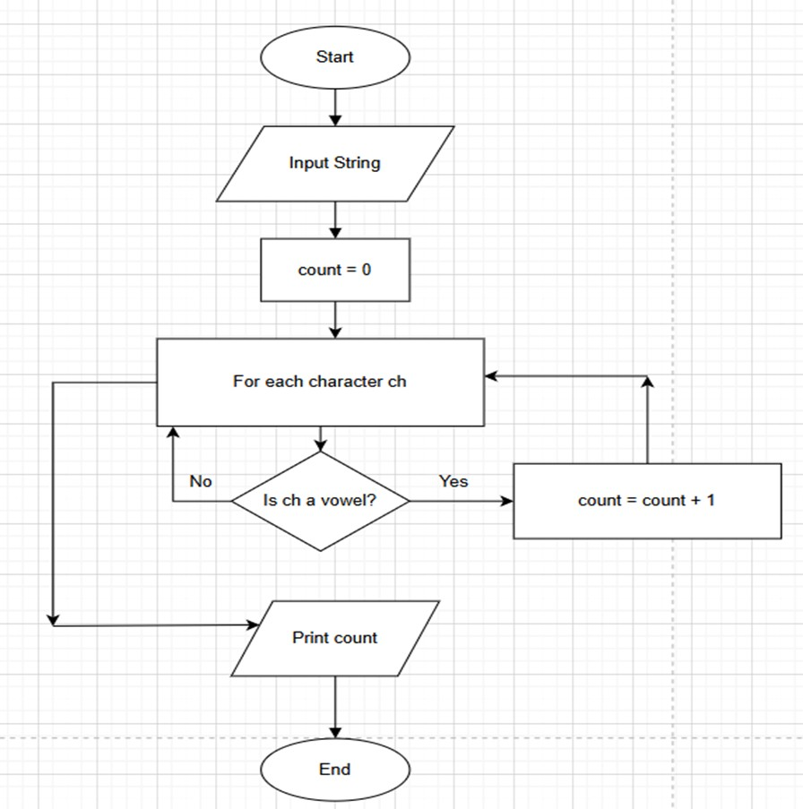
str = input() count=0 for i in str:
if i in['A','E','I','O','U','a','e','i','o','u']:
count += 1
print(count)
- Execution :